# Installing R and RStudio

### Getting and installing R

The installation of R depends on the operating system to be used. You can find all the necessary information in:

* <http://cran.r-project.org/>

For the development of this course I will use the Windows version but feel free to use whatever version fits your needs. The last version of R is downloadable from [here](https://cran.r-project.org/bin/windows/base/) (R version 4.0.4). I will use R it in Windows 64-bit. Remember that you have to install the version that corresponds to the architecture of your OS (32 or 64 bits, Windows or Linux). **In case of doubt install both versions or at least the 32-bit version, which will always work on our computer.**

Installation for Windows

On the website, click “Download R for Windows”, the following page will show up

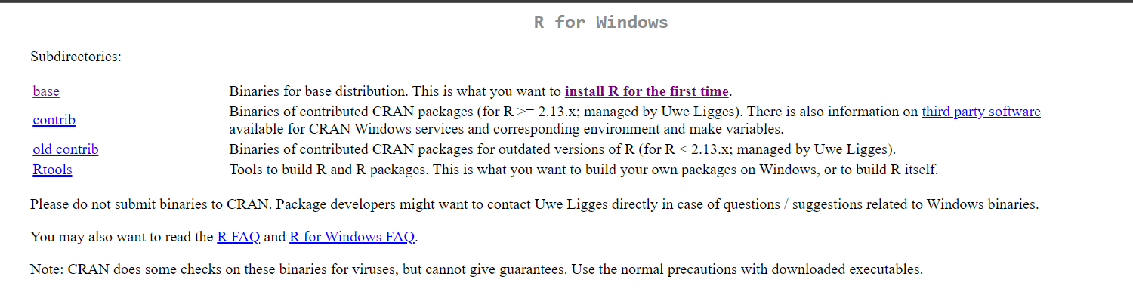

Then click “Install R for the first time”. You will be directed to the following page:

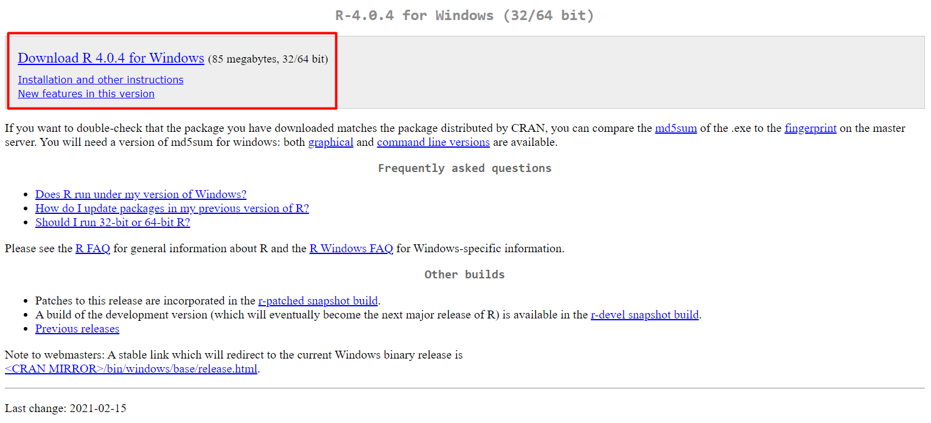

Then click “Download R 4.0.4” it contains .exe files for both 32 and 64 bit.

Installation in Windows is very simple. Just run the executable (.exe) file and follow the installation steps (basically say *Yes* to everything). Once R is installed, we will install **RStudio** an integrated development environment (IDE) that is more user-friendly than the basic R interface. Just install it for now and I will explain why do we need it.

For macOS, on the page <http://cran.r-project.org/> click “Download R for Mac (OS)”. You will be directed to the following page:

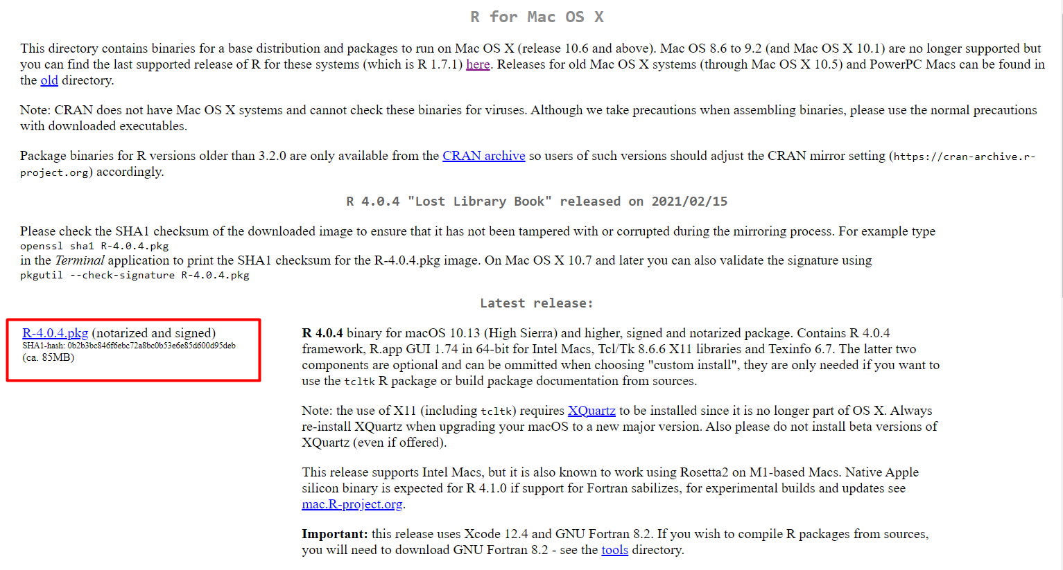

Install the .pkg file that I marked in the screenshot. Unfortunately I don’t use MacOS so I don’t know how the installation will go. I’m sure that the installation will work fine if you have the latest version of macOS, but I may not be able to help you if you have to download the older version of R due to the old version of your macOS (i.e. macOS 8.6 to 9.2). If you download this older version, some packages that I will run through the practicum may not be supported as well. If you happen to have older version of macOS, send me an email ([firzariany2@gmail.com](mailto:firzariany2@gmail.com)).

If you don’t know the version of your Windows or macOS, google the procedure.

### Installing RStudio

We will install the latest version of [RStudio](https://www.rstudio.com/products/rstudio/download/).

* Note that RStudio is just an *interface*. Any code block or instruction will work in any other R environment.
* **Before installing RStudio you need to have already installed the standard R software.**

Choose the free package of RStudio 🡪 download

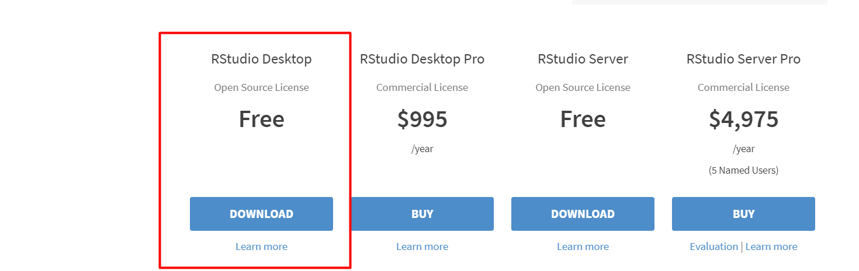

In the previous steps you have already installed R. So, just go ahead and install RStudio as shown by the button. This version is only suitable for Windows 64-bit.

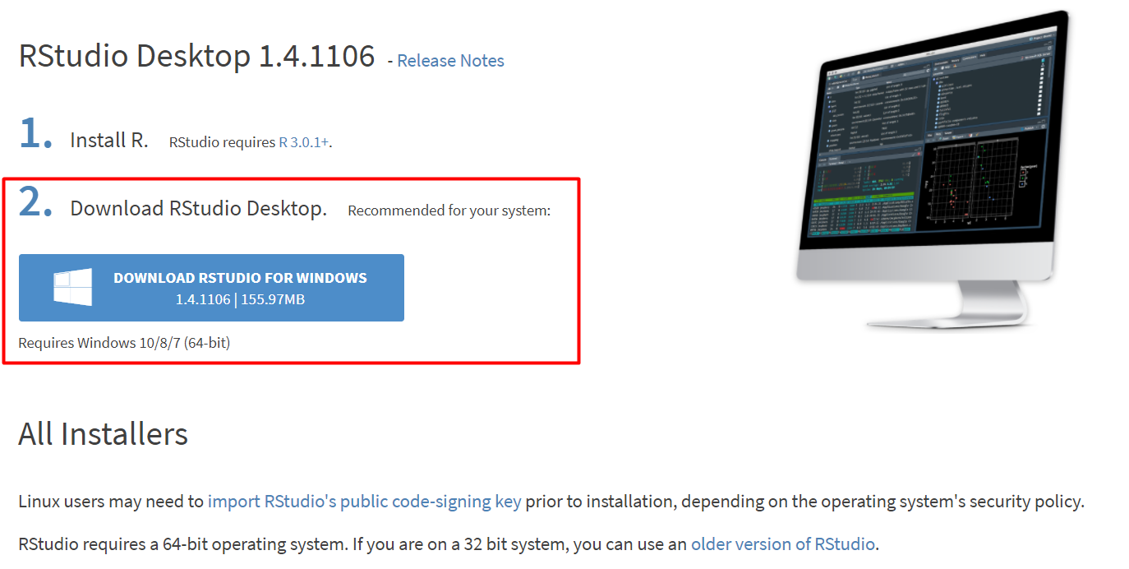

For other operating systems: scroll down the page, and you will see this list

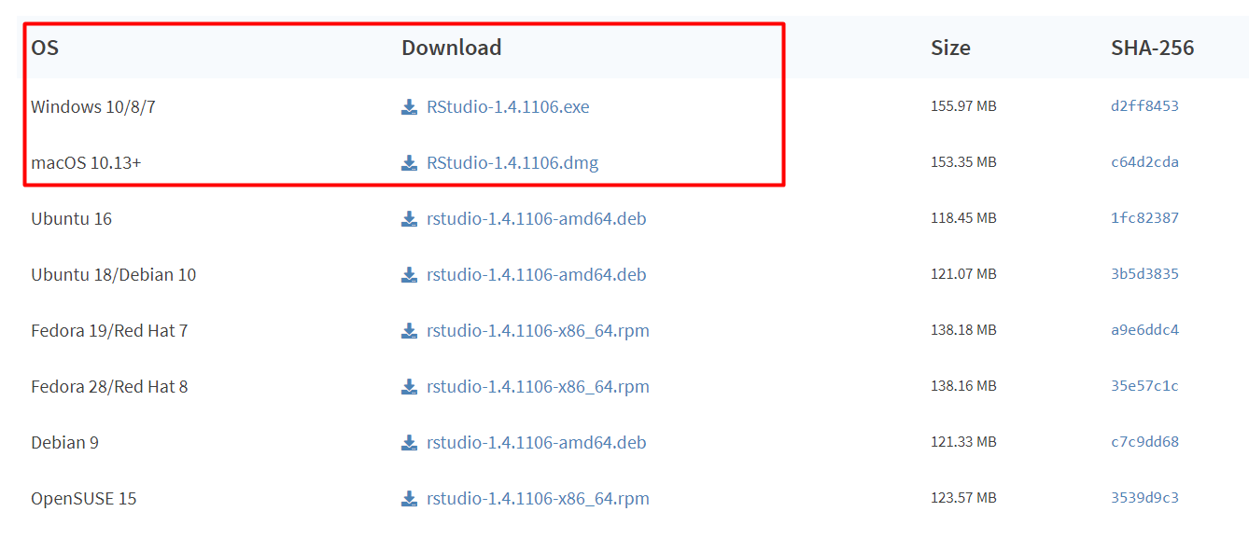

For Windows 32-bit users, check this version: [Older Versions of RStudio - RStudio](https://rstudio.com/products/rstudio/older-versions/)

